**ASSIGNMENT -3**

**HARSH RAJ**

**J011**

**ANDRIOD APP DEVELOPMENT**

**MAIN ACTIVITY XML FILE**

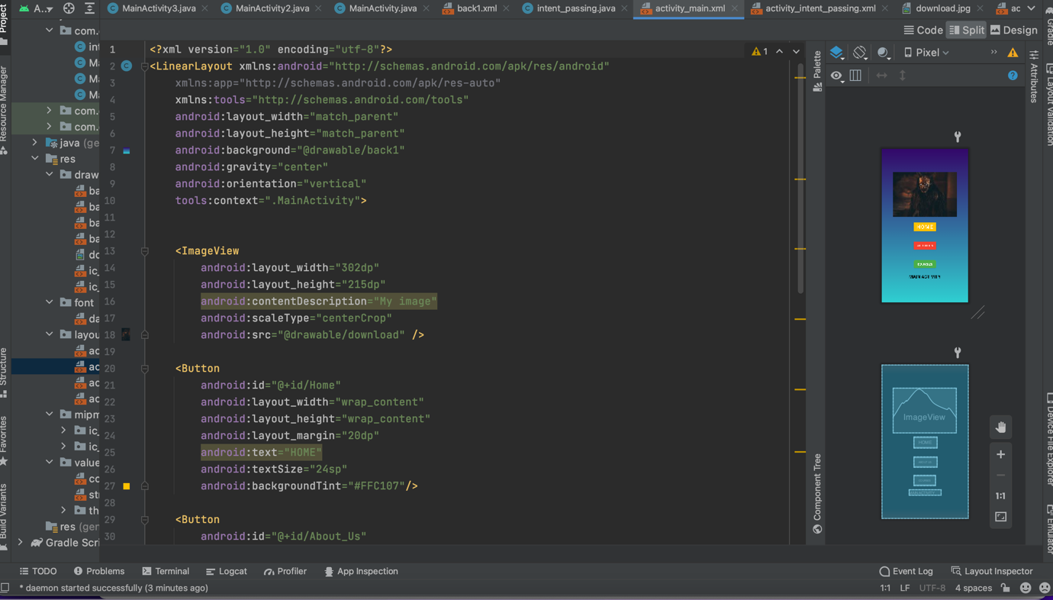

**HOME PAGE XML FILE**

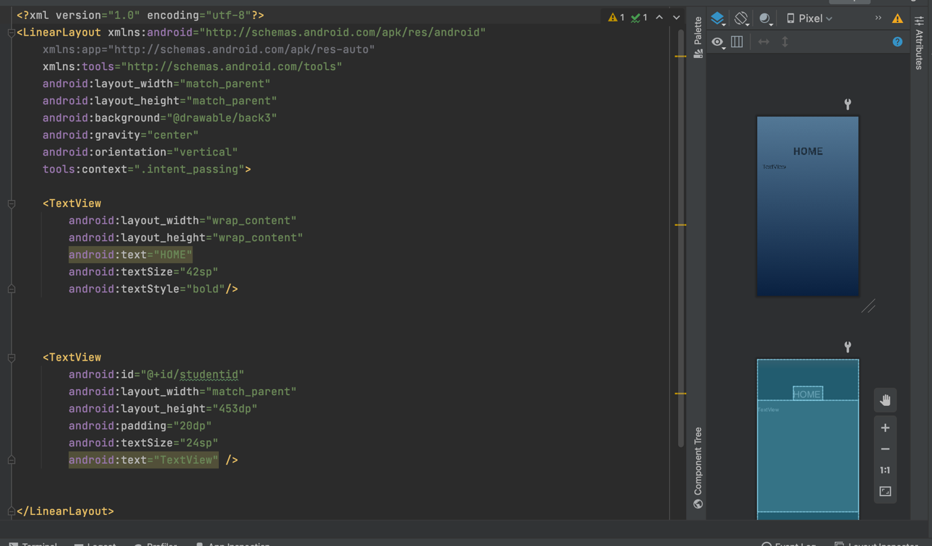

**ABOUT US XML PAGE**

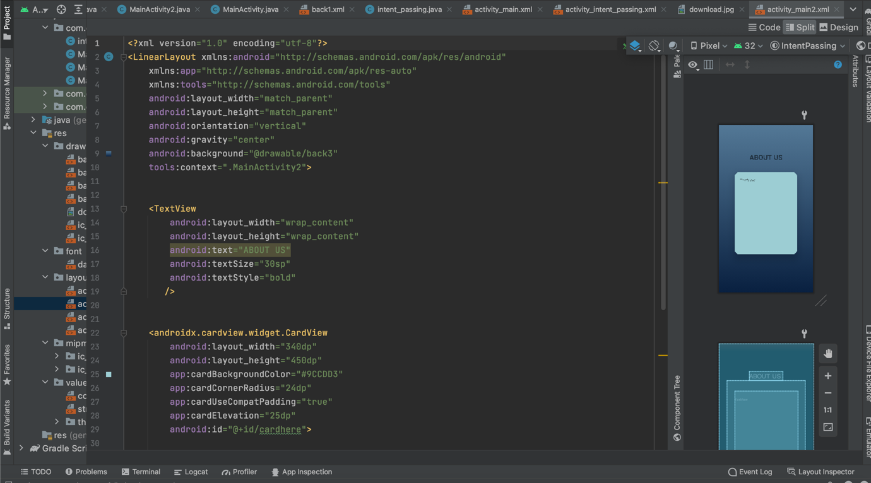

**COURSES XML PAGE**

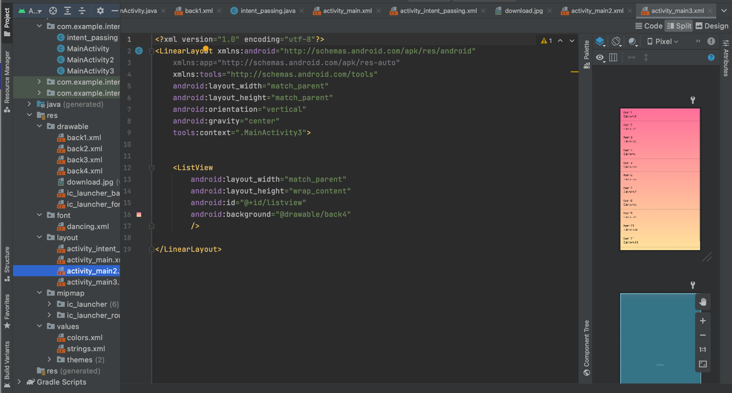

**MAIN ACTIVITY JAVA CODE**

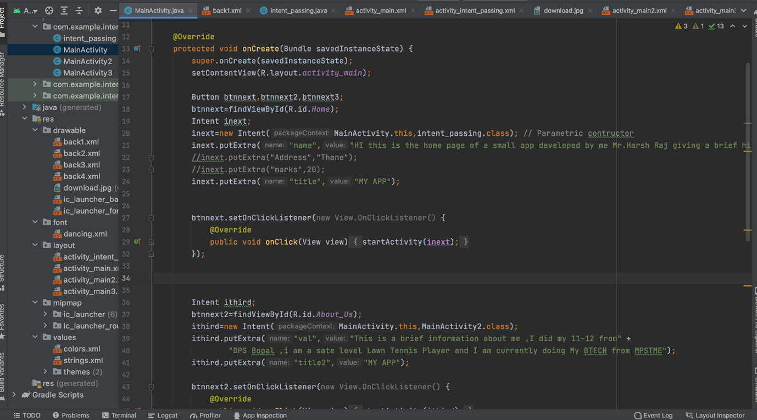

**HOME PAGE JAVA CODE**

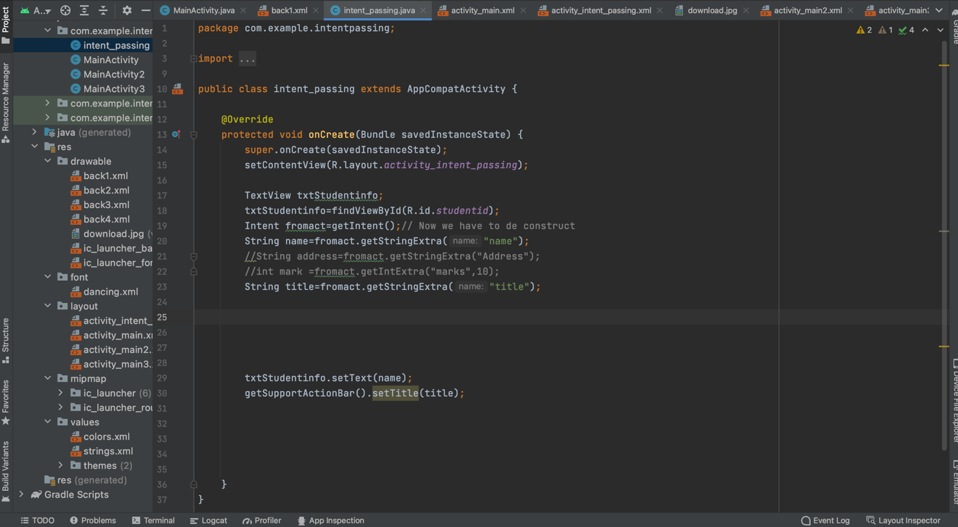

**ABOUT PAGE JAVA CODE**

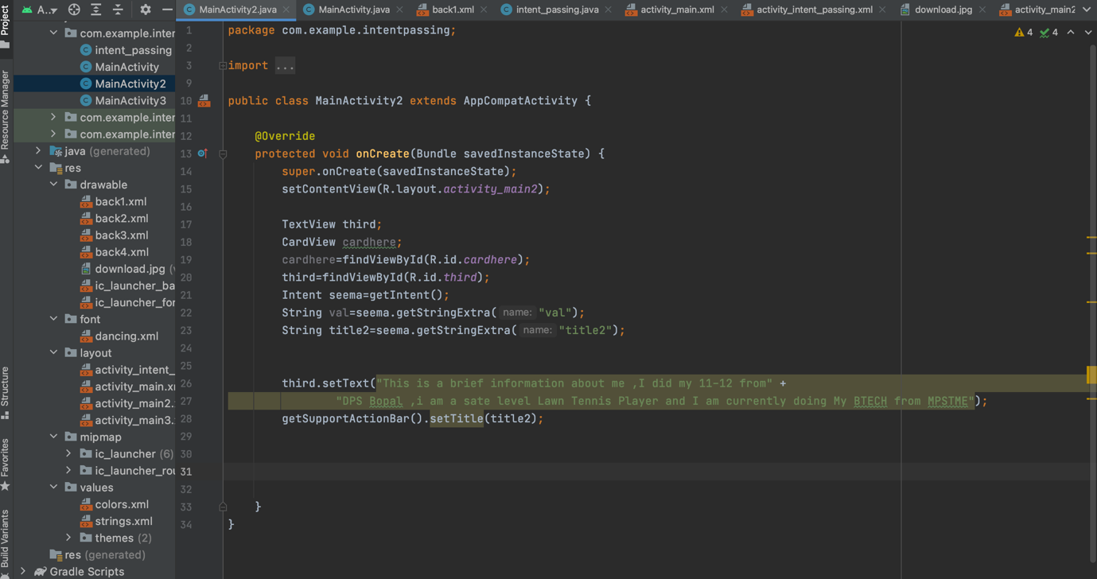

**COURSES PAGE JAVA CODE**

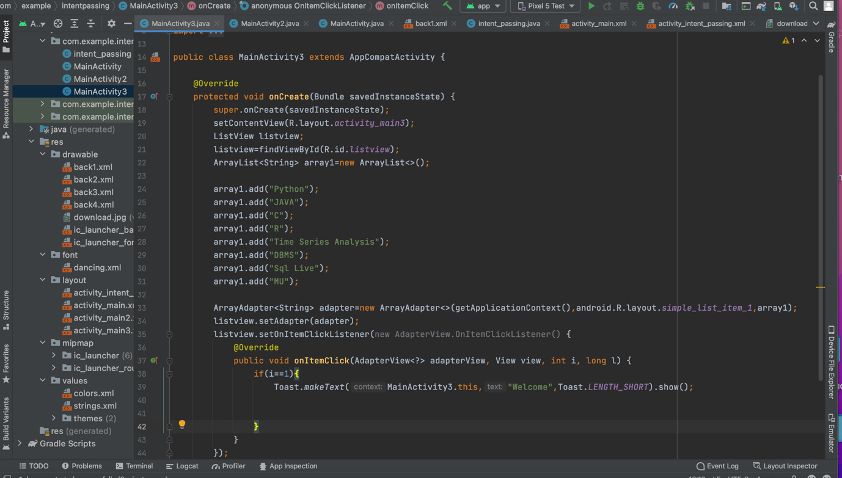

**UI**

